**Introduction to Game development**

**2D Tower Defense game**

**Adilet Zhaksylyk**

**SE-2207**

**Topic:** 2D Tower defense game

**INTRODUCTION:**

My project is a 2D Tower defense game developed using Unity and C#. In this report, I will provide a brief overview of the project, discuss the objectives, and highlight the importance and relevance of developing a 2D Roguelike game.

**Goal:** to create an engaging and challenging game experience for players.

**GAME`s Goal:** To complete levels, to defend base by using turrets to defeat enemies and not allow them to enter into base

**DEVELOPMENT PROCESS:**

The development process included several stages, including planning, design, implementation and testing. We used various tools and technologies, such as Unity for game development and C# for scripting.

**GAME DESCRIPTION:**

In my 2D Game, players must defend their bases from enemy waves. There are two type of enemies, such as tanks and troops. To defend base player is able to place turrets with rockets, every of them has different characteristics, and right placement will help player to win

**TECHNICAL DETAILS:**

The architecture of the game is designed in such a way as to ensure modularity and scalability. Key systems, including placement of turrets, enemy animations, and shooting system, have been implemented to ensure smooth gameplay. During development, I encountered a number of problems, such as optimizing performance and balancing game mechanics. Through careful problem solving and iteration, we were able to overcome these difficulties and create a high-quality game.

Here you can get acquainted with the sprites used.

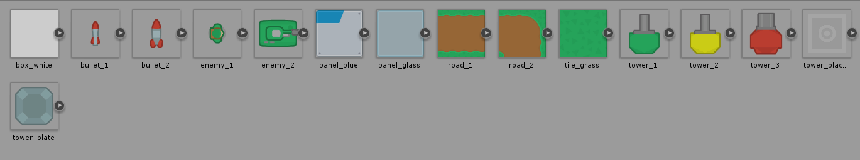

Here you can get acquainted with the scripts.

Here you can get acquainted with the assets.

Hierarchy of 1st scene, level

**TESTING AND QUALITY ASSURANCE:**

To ensure a bug-free and enjoyable gaming experience, I employed various testing methodologies, including functional testing, compatibility testing, and playtesting. Throughout the testing phase, we encountered and addressed several bugs and issues to improve the game's overall quality. Feedback from testing was crucial in identifying areas for improvement and implementing necessary changes.

**REFLECTION AND CRICITCAL ANALYSIS:**

This project was a great experience for me, I studied a lot of new features and tools that can be used in game development and understood a lot of processes and mechanics for it. I also improved my abilities in information searching and filtering. A lot of information, methods are invented and most of them can be used in many games. Such work also gave me great experience in bug checking, however, I am on the way of learning the bug fixing process